
CSF3133 K4 REKA BENTUK ANTARA MUKA BERASASKAN WEB
SEM 3
LAB REPORT 3

PREPARED FOR:
ASSOC. PROF. TS. DR. WAN NURAL JWAHIR
LAB ASSISTANT:
MADAM WAN FATIN

PREPARED BY:
NUR ADLYNN SYAKIRAH BINTI NOR KHAIRUL ANUAR
NO. MATRIC:
S76245

SUBMIT BY:
5 NOVEMBER 2025
ACTIVITY 3.2
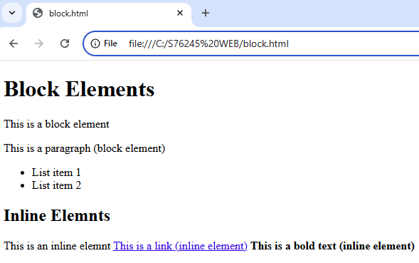

ACTIVITY 3.3
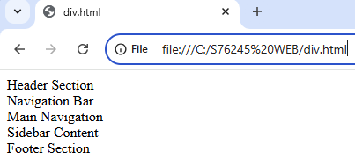

ACTIVITY 3.4
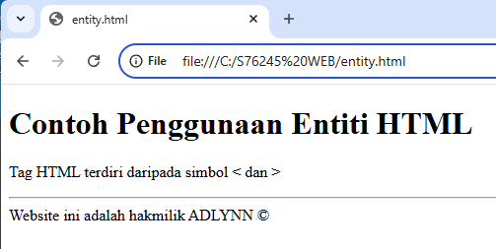

ACTIVITY 3.5
Before:
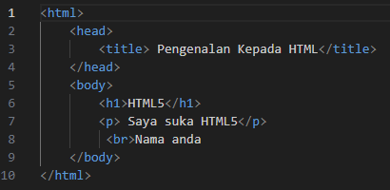
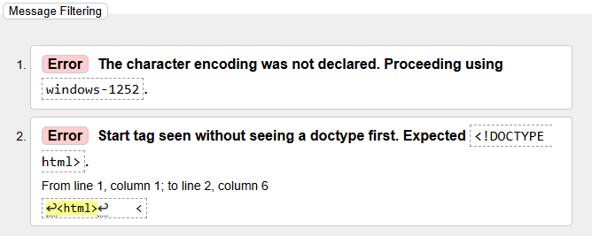
Conclusion: The missing <!DOCTYPE html> declaration should be added at the top to ensure proper HTML5 rendering

After:
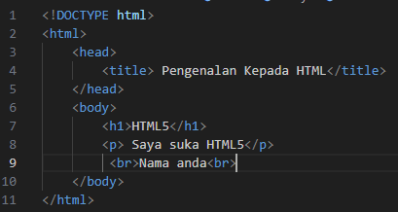
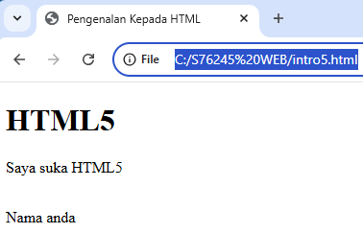
ACTIVITY 3.6.1
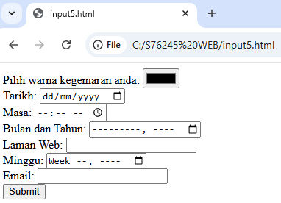
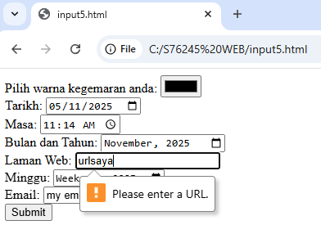
- Because the data type is url

ACTIVITY 3.6.2
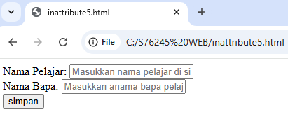

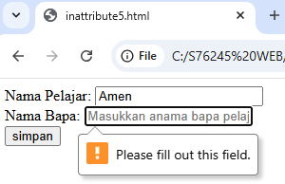
- Cannot save because the father name is required
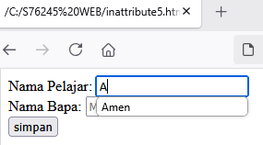
- There is autocomplete occur
ACTIVITY 3.6.3
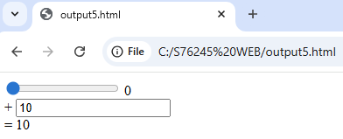

LAB EXERCISE
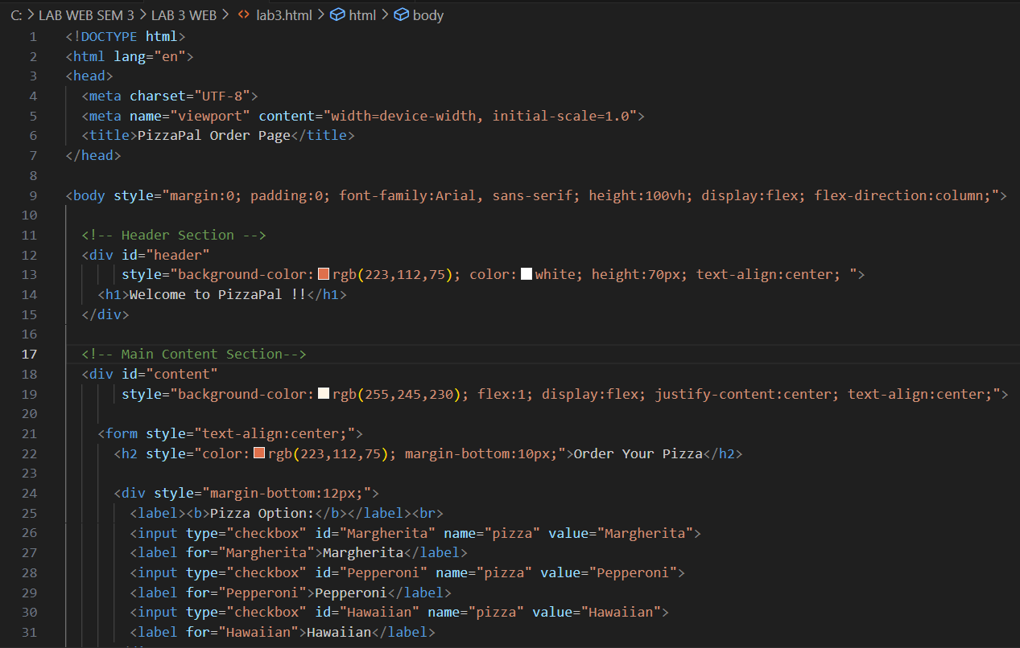
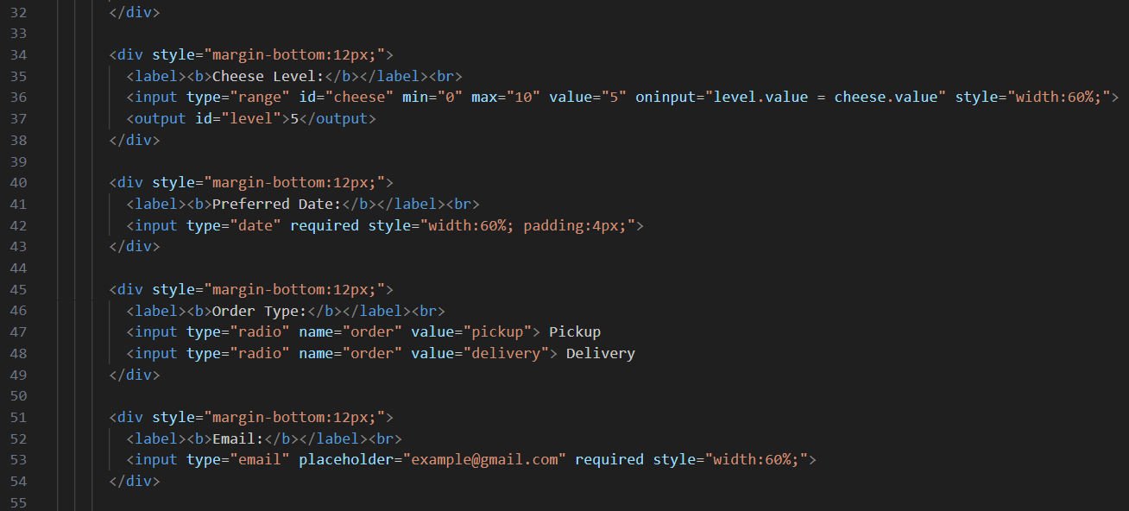
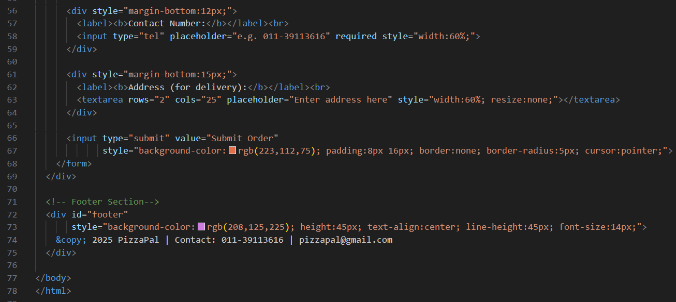
OUTPUT
